Shaheer Ul Aziz
GRAPHIC DESIGNER
I’m a Graphic Designer with 6+ years of experience and have worked with 100+ international clients across a variety of industries. I enjoy turning ideas into clean, eye-catching designs that not only look good but also communicate the right message.

Skills
Video Editing

AI Tools

Graphic Design

Social Media
My work includes social media posts, ads, branding, web and print materials, thumbnails, banners, and other marketing content. I specialize in modern, minimalist designs that are clear, attractive, and memorable.

Alongside graphic design, I also have experience in social media, video editing, and AI tools. This helps me understand the bigger picture and create content that works well across different platforms.

I’m always learning, exploring new tools, and finding better ways to work. Whether I’m helping a startup build its identity or supporting an established brand, my goal is simple: create designs that make an impact and help businesses grow.

If you're looking for a designer who values clarity, creativity, and attention to detail, feel free to connect!


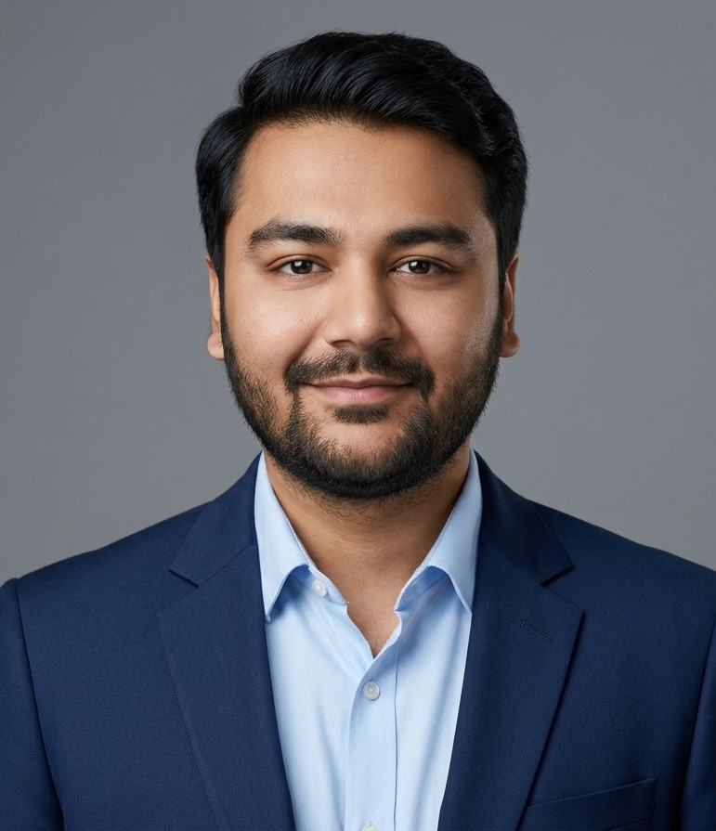
Certifications

DigiSkills
Graphic Design Course

Udemy
Graphic Design Masterclass Course

Links

Chat on WhatsApp
+92 3256896536

Visit My Portfolio
www.behance.net/shaheerulaziz1

Send an Email
suafeb29@outlook.com

View full Resume on LinkedIn
www.linkedin.com/in/shaheer-ul-aziz/

Check my Facebook Page
facebook.com/people/Shaheer-Ul-Aziz

Check my YouTube Channel
www.youtube.com/@ShaheerDesigns313

Experience

Jan 2020 - Jan 2023
Fiverr | Freelance
Completed a lot of Freelance Design Projects.

My Services:
- Logo Design - T-Shirt Design - Post Design
- Thumbnail Design - Banner Design - Vector Tracing

May 2023 - Jan 2026
Tommy Sugo | Nathan Baws | Remote Job
Worked remotely for an Australian Businessman, Nathan Baws and his businesses, particularly Tommy Sugo.
Tasks:
- Social Media Design - Reels E Short Videos
- Web E Print Design - Social Media Management

Feb 2026 - Present
Freelancer | Remote Worker | Content Creator
Currently building my presence on various online platforms. Offering Freelance Services as well availability for a Remote position.

Platforms:
- Behance - LinkedIn - Facebook - Instagram - YouTube

Services:
- Graphic Design - Video Editing - Social Media - AI

